CIM-CS-01 Business Master Data – Manage Business Partner – ECC/C4C

Table of Contents
1 Overview 2
1.1 Functional Area(s) – Mark all applicable with X 2
1.2 Configuration Team Member 2
1.3 Baseline Configuration Details 2
1.4 Change Log(s) 3
2 S/4HANA Configuration Details 4
2.1 Define Number Ranges 4
2.2 Define Groupings and Assign Number Ranges 4
2.3 Activate Application 5
2.4 Table COM_BUPA_CALL_FU 6
2.5 Synchronization Objects 6
2.6 Activate PPO Requests for Platform Objects in the Dialog 7
2.7 Activate Synchronization Options 7
2.8 Activation Switch for Functions 8
2.9 Define Number Assignment for Direction BP to Customer 9
2.10 Activation Switch for Functions 10
2.11 Define Address Types 11
2.12 Define Identification Categories 12
2.13 Define Identification Types 14
2.14 Define BP Roles 15
2.15 Define BP Roles Groupings 17
2.16 Define BP Relationships 17
2.17 Define Attributes 20
2.18 Define Status Profile 22
3 C4C Configuration Details 26
3.1 General Information 26
3.2 Define Number Ranges in C4C 28
3.3 Define BP Relationships in C4C 29
3.4 Adding Fields to Various Screens in C4C 30

Overview

Functional Area(s) – Mark all applicable with X
Customer Interaction (CIM) | X | Device & Field (DF)
C4C (Sales / Service) |  | Case Management (CM)
Credit & Collections (CC) |  | Usage & Billing: BI (UB)
IDEX (ID) |  | Usage & Billing: DM (UB)
Analytics (AN) |  | Finance (FI)
BASIS |  | Payments (PY)
Products & Programs (PP) |  | Technical

Configuration Team Member
Name | Diego Lopes/Jessica Marsillo
Team | CIM
Integration Points | All

Baseline Configuration Details
Date | 01/25/2018
Config Details | A Business Partner (BP) is an individual or organization with whom Southern California Edison has a relationship. Master data, or information, that is maintained for a BP is either considered cross-component data, which is data that is available across the entire enterprise or role-specific data, which is data that is tied to the specific type of BP being maintained (e.g. the detailed data captured for the role of ‘Prospect’ would be different from the role of ‘Sold-to Party’).  In Southern California Edison SAP environment a BP will exist in both the Front Office and Back Office landscapes, and any creation or change made in one system will be replicated into the other. The unique identifier that is used in creating the BP in one environment will be the same unique identifier used in the other environment as well.  This document contains all the configuration related to the business partner in both in Back Office regardless if category person or Organization.
Config “Where Used” | This configuration will be used in Back Office transaction BP. All the information available in the GUI transaction is configured in this document.

Change Log(s)
Change Date | [Date of change, in MM/DD/YYYY format]
Change Made By | [Name of who made the change]
Change Authorized | [Name of who authorized the change]
Change Details | [Provide the details about the change to the configuration using similar details as with the original configuration. ie if a new value was added, will a FRICEW or other integrated area be impacted and be required to update their configuration or FRICEW items.]

S/4HANA Configuration Details

Define Number Ranges
- Transaction | BUCF | Define Number Ranges
Menu Path | Cross-Application Components SAP Business Partner Business Partner Basic Settings Number Ranges and Groupings Define Number Ranges

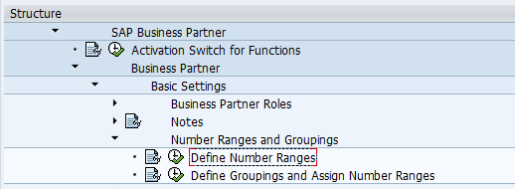

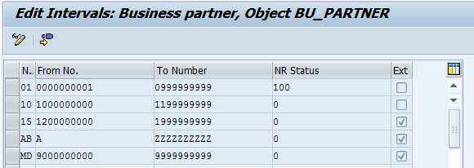

Define Groupings and Assign Number Ranges
- Transaction | SPRO | Define Groupings and Assign Number Ranges
Menu Path | Cross-Application Components SAP Business Partner Business Partner Basic Settings Number Ranges and Groupings Define Groupings and Assign Number Ranges

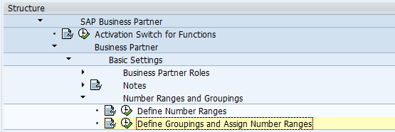

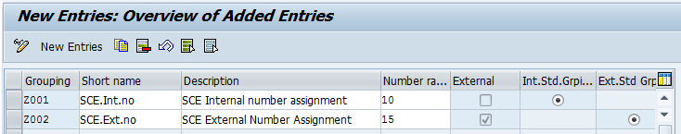

Activate Application
- Transaction | BUS1 | Activate Application
Menu Path | N/A

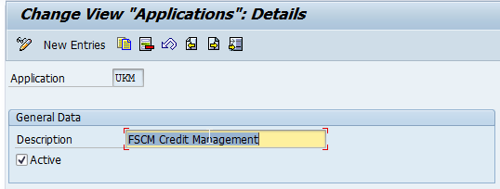

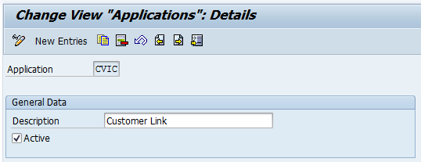

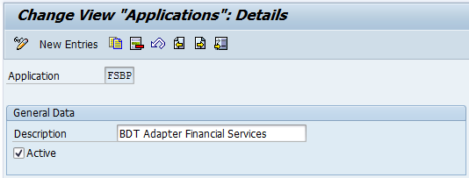

Table COM_BUPA_CALL_FU
- Transaction | SM30 | Table COM_BUPA_CALL_FU
Menu Path | N/A

Time | Object | Item | Function Module Name | Call
AFCVI | BUPA | 2000000 | ISU_COM_BUPA_MAIN_AFCVI | X
BFCVI | BUPA | 2000000 | ISU_COM_BUPA_MAIN_BFCVI | X
R3IN | BUPA | 2000 | ISU_BUPA_MWX_FILTER_MAIN | X
R3IN | BUPA | 5000 | COM_BUPA_MWX_FILTER_ISU | X
R3IN | BUPA | 50000 | COM_BUPA_MWX_MAP_NUMRANGE | X
R3OBI | BUPA | 1000000 | PI_BP_PROXY_BAPI_CUSTOMER
R3OBI | BUPR | 1000000 | PI_BP_PROXY_BAPI_CUSTOMER
R3OBO | BUPA | 1000000 | COM_BUPA_MWX_CREATE_MAIN | X
R3OUT | BUPA | 1000 | ISU_BUPA_MWX_BPS_FILL_CENTRAL | X
R3OUT | BUPA | 160000 | ISU_BUPA_CVI_OUTBOUND_MWX_CHK | X
R3OUT | BUPA | 200000 | CMD_COM_BUPA_MWX_BPS_FILL | X
R3OUT | BUPR | 200000 | CMD_COM_BUPA_MWX_BPR_FILL | X

Synchronization Objects
- Transaction | SPRO | Synchronization Objects
Menu Path | Cross-Application Components Master Data Synchronization Synchronization Control Synchronization Control Synchronization Objects

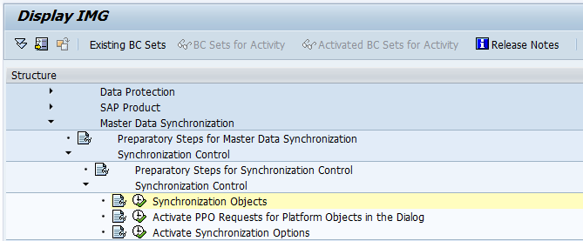
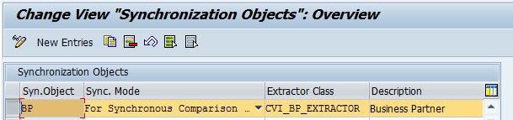

Activate PPO Requests for Platform Objects in the Dialog
Transaction | SPRO | Activate PPO Requests for Platform Objects in the Dialog
Menu Path | Cross-Application Components Master Data Synchronization Synchronization Control Synchronization Control Activate PPO Requests for Platform Objects in the Dialog

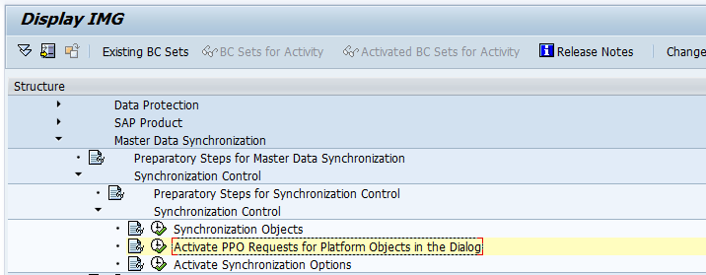

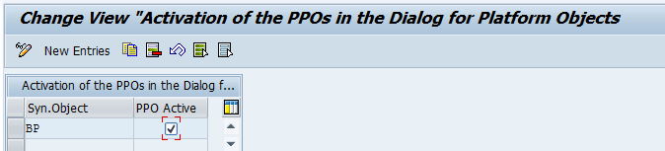

Activate Synchronization Options
Transaction | SPRO | Activate Synchronization Options
Menu Path | Cross-Application Components Master Data Synchronization Synchronization Control Synchronization Control Activate Synchronization Options

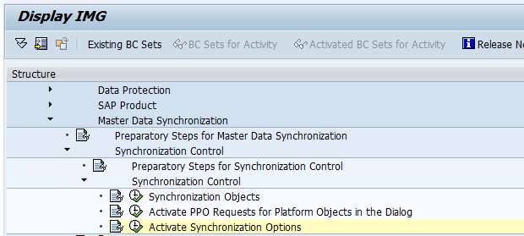

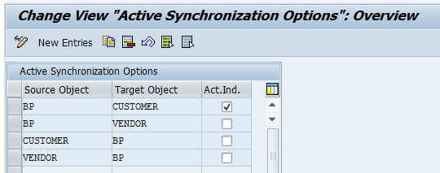

Activation Switch for Functions
Transaction | SPRO | Activation Switch for Functions
Menu Path | Cross-Application Components Master Data Synchronization Customer/Vendor Integration Business Partner Settings Settings for Customer Integration Set BP Role Category for Direction BP to Customer

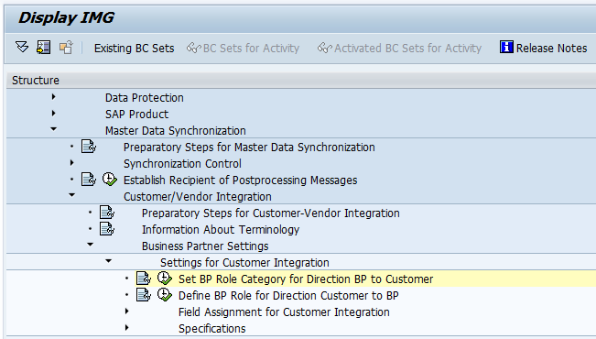

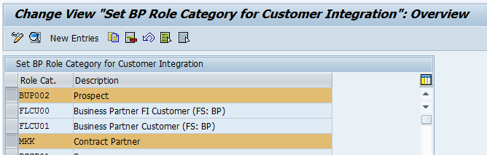

Define Number Assignment for Direction BP to Customer

Transaction | SPRO | Define Number Assignment for Direction BP to Customer
Menu Path | Cross-Application Components Master Data Synchronization Customer/Vendor Integration Business Partner Settings Settings for Customer Integration Field Assignment for Customer Integration Assign Keys Define Number Assignment for Direction BP to Customer

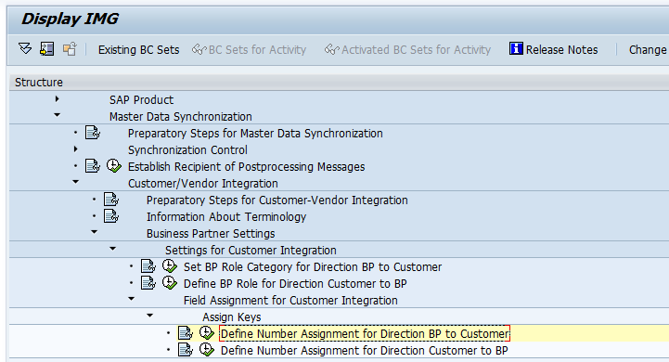

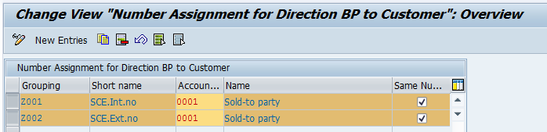

Activation Switch for Functions
Transaction | SPRO | Activation Switch for Functions
Menu Path | Cross-Application Components SAP Business Partner Activation Switch for Functions

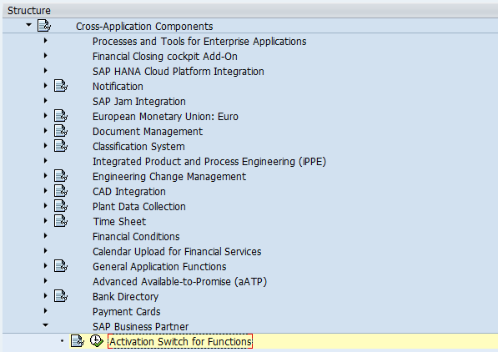

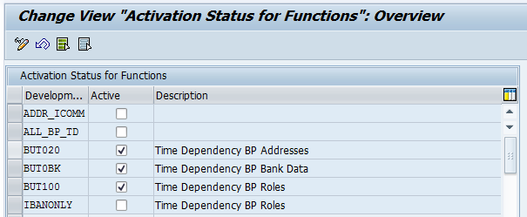

Define Address Types
Transaction | SPRO | Define Address Types
Menu Path | Cross-Application Components SAP Business Partner Business Partner Basic Settings Address Determination Define Address Types

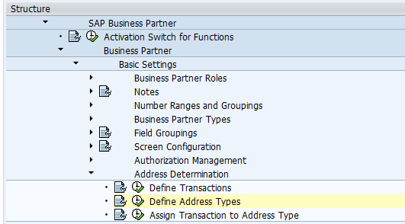

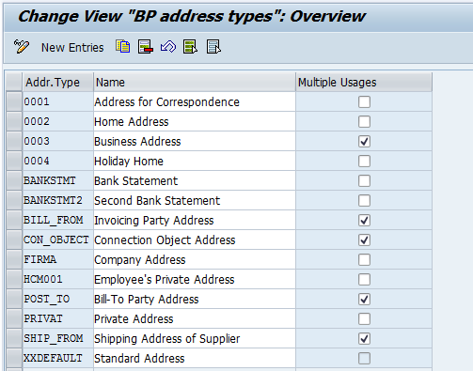

Define Identification Categories
Transaction | SPRO | Define Identification Categories
Menu Path | Cross-Application Components SAP Business Partner Business Partner Basic Settings Identification Numbers Define Identification Categories

**Identification Categories needs to be configured before Identification Types. See excel attachment in Section 2.13 for what has currently been configured for both**
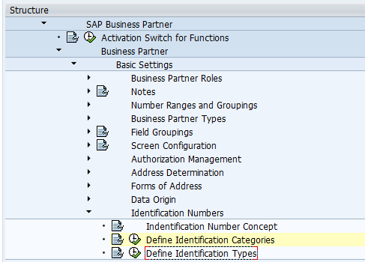

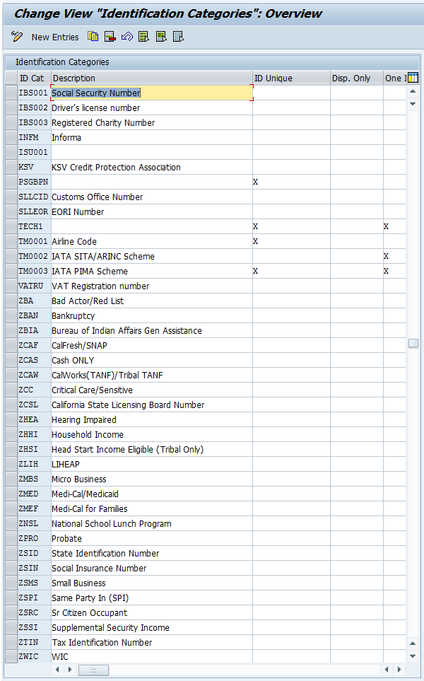

Define Identification Types
Transaction | SPRO | Define Identification Types
Menu Path | Cross-Application Components SAP Business Partner Business Partner Basic Settings Identification Numbers Define Identification Types

Identification Types currently configured:
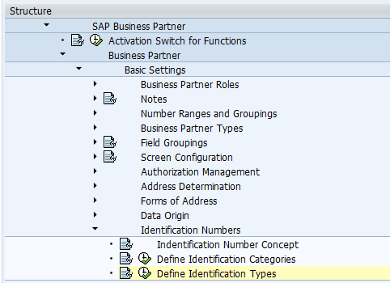

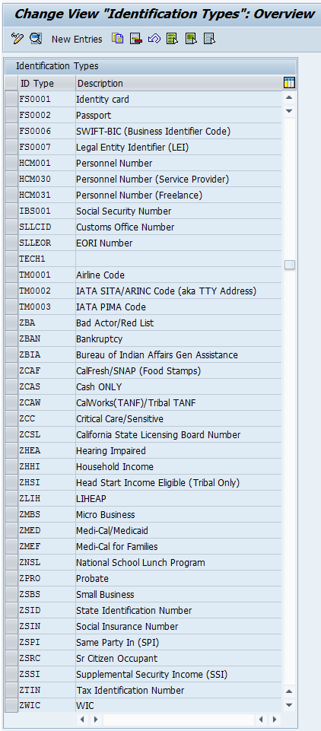

Define BP Roles
Transaction | SPRO | Define BP Roles
Menu Path | Cross-Application Components SAP Business Partner Basic Settings Business Partner Roles Define BP Roles

BP Roles currently configured:

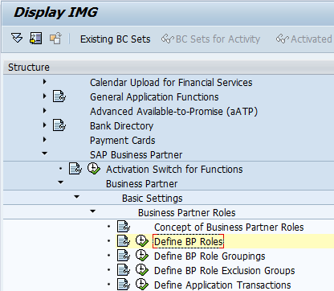

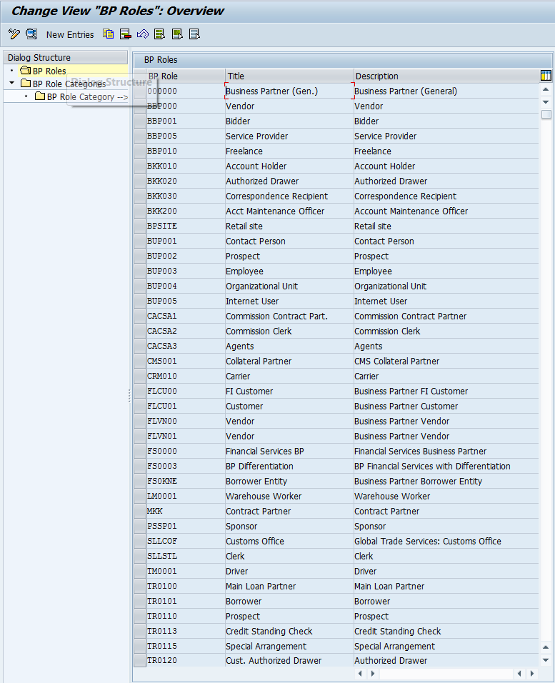

Define BP Roles Groupings
Transaction | SPRO | Define BP Role Groupings
Menu Path | Cross-Application Components SAP Business Partner Basic Settings Business Partner Roles Define BP Role Groupings

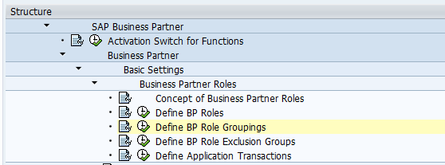

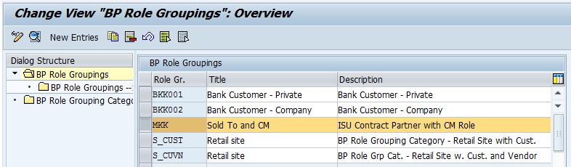

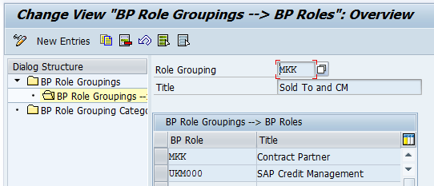

Define BP Relationships
Transaction | BPUT | Define BP Relationships
Menu Path | Business Partner Relationships Control Relationship Categories

BP Relationships currently configured:
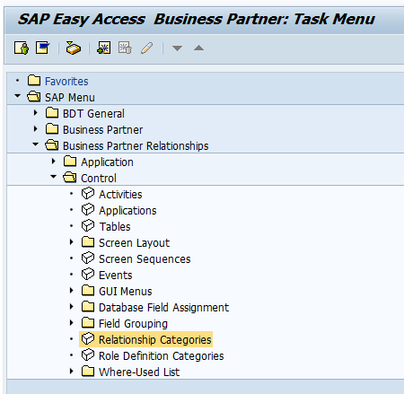
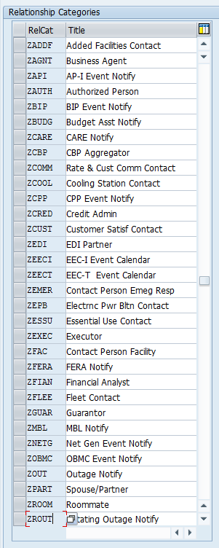

Define Attributes
Transaction | SPRO | Define BP Relationships
Menu Path | Logistics - General Business Partner Customers Control Define Attributes

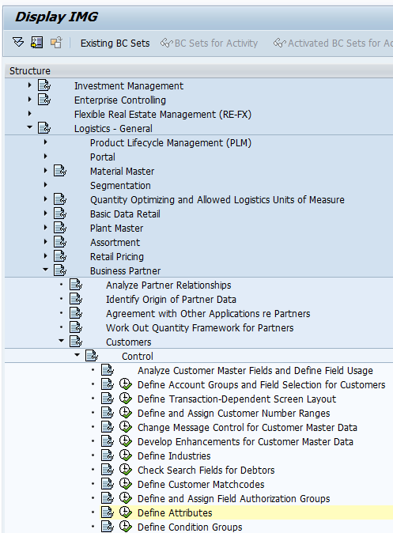

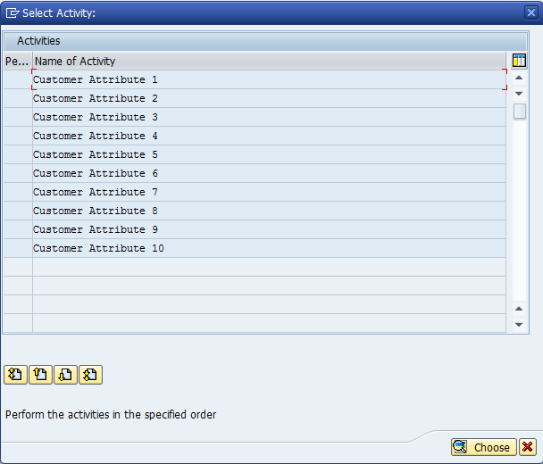
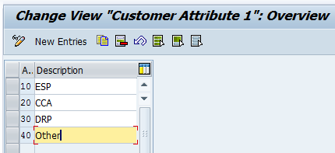
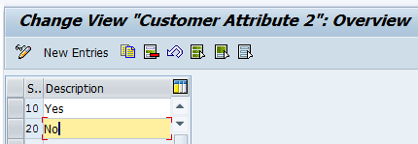
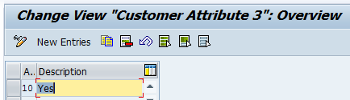
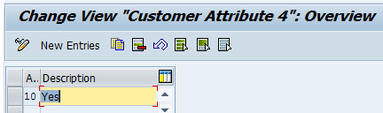

Define Status Profile
Transaction | SPRO (or BS02) | Define Status Profile
Menu Path | Cross-Application Components SAP Business Partner Business Partner Basic Settings Status Management Define Status Profile for User Status

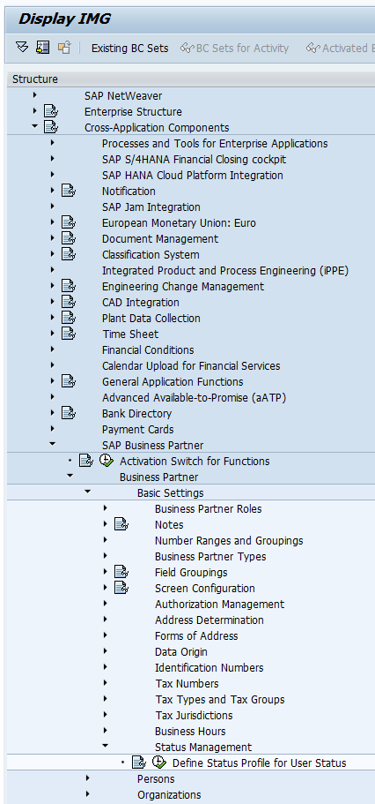
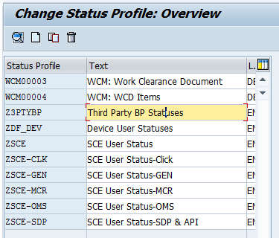
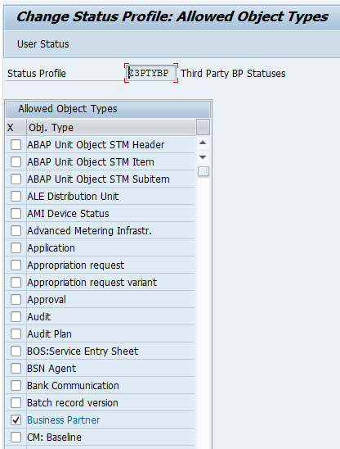
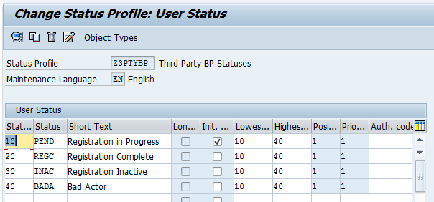

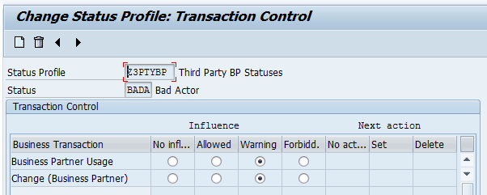

C4C Configuration Details

General Information
Transaction | N/A | General Information to Begin Configuration
Menu Path | https://my337269.crm.ondemand.com

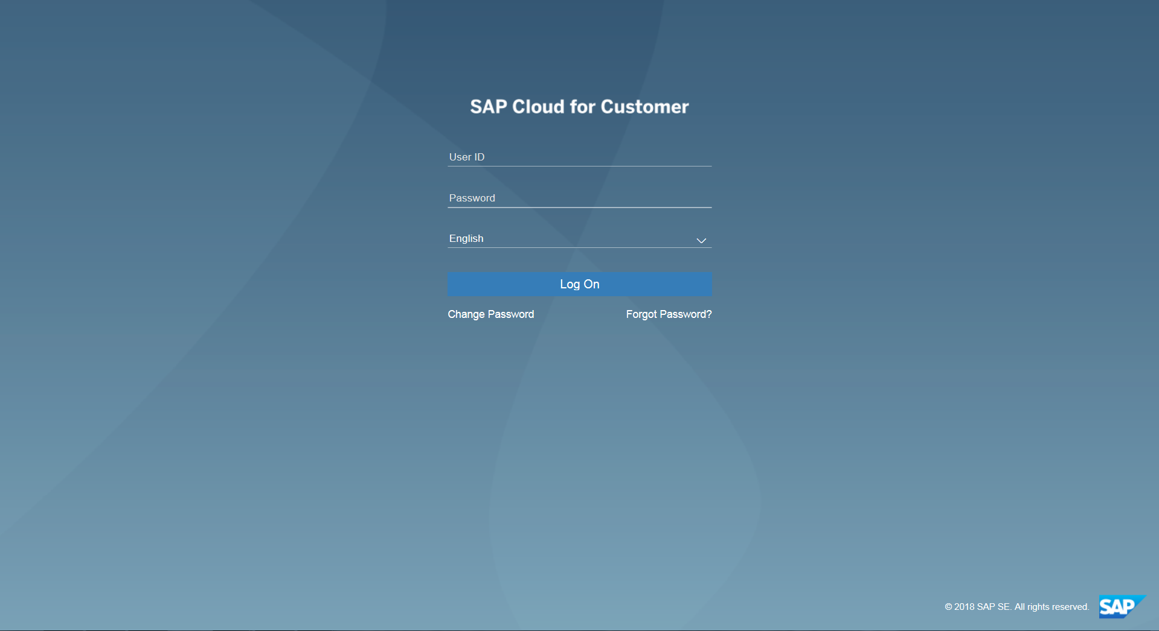
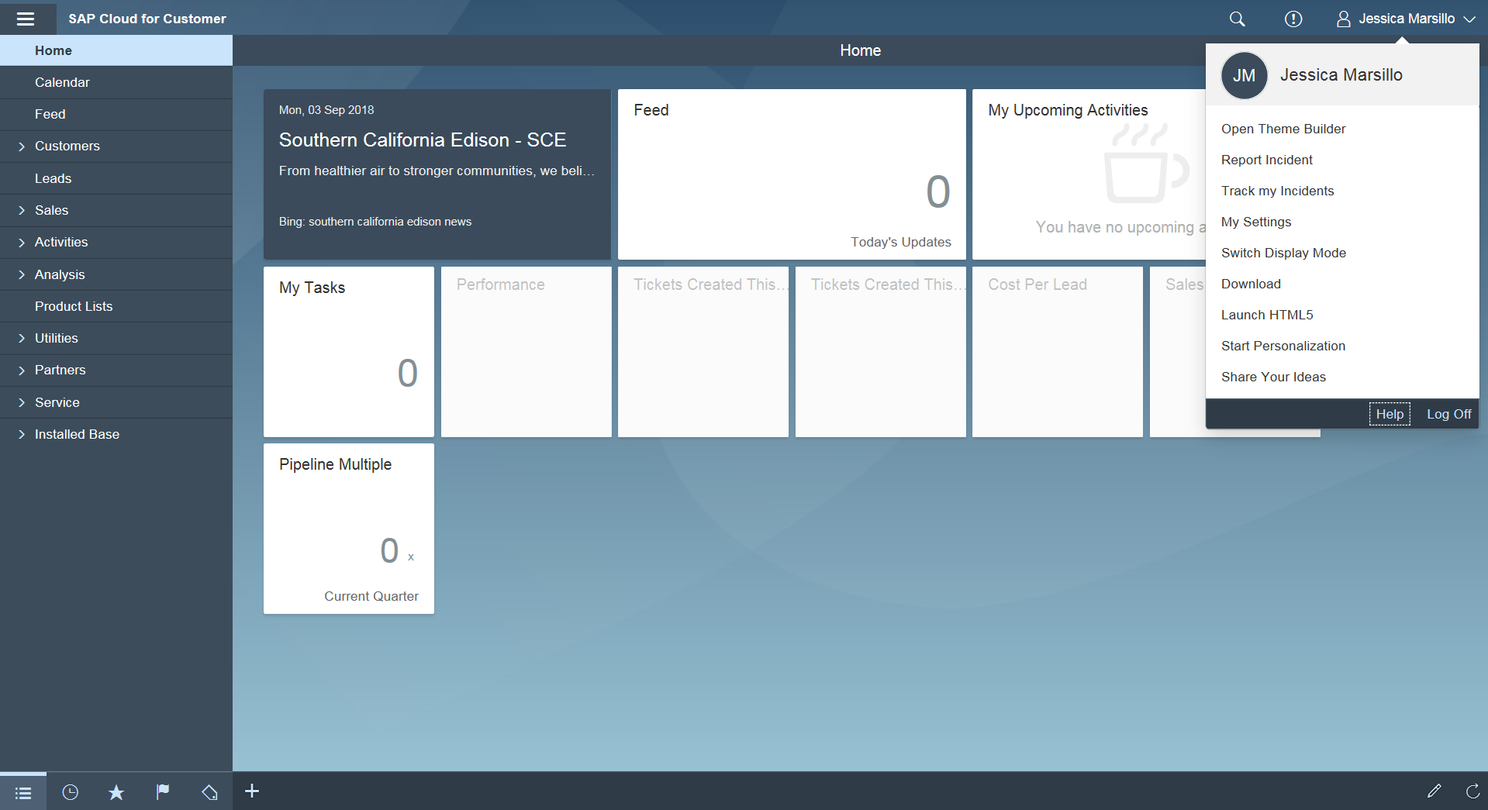
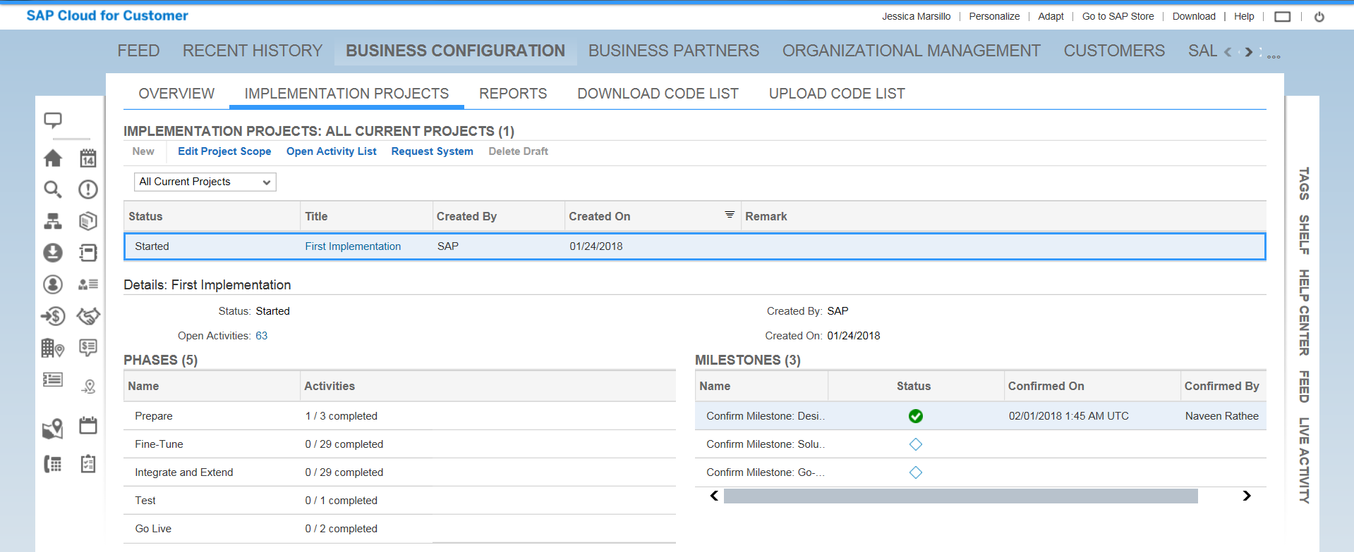
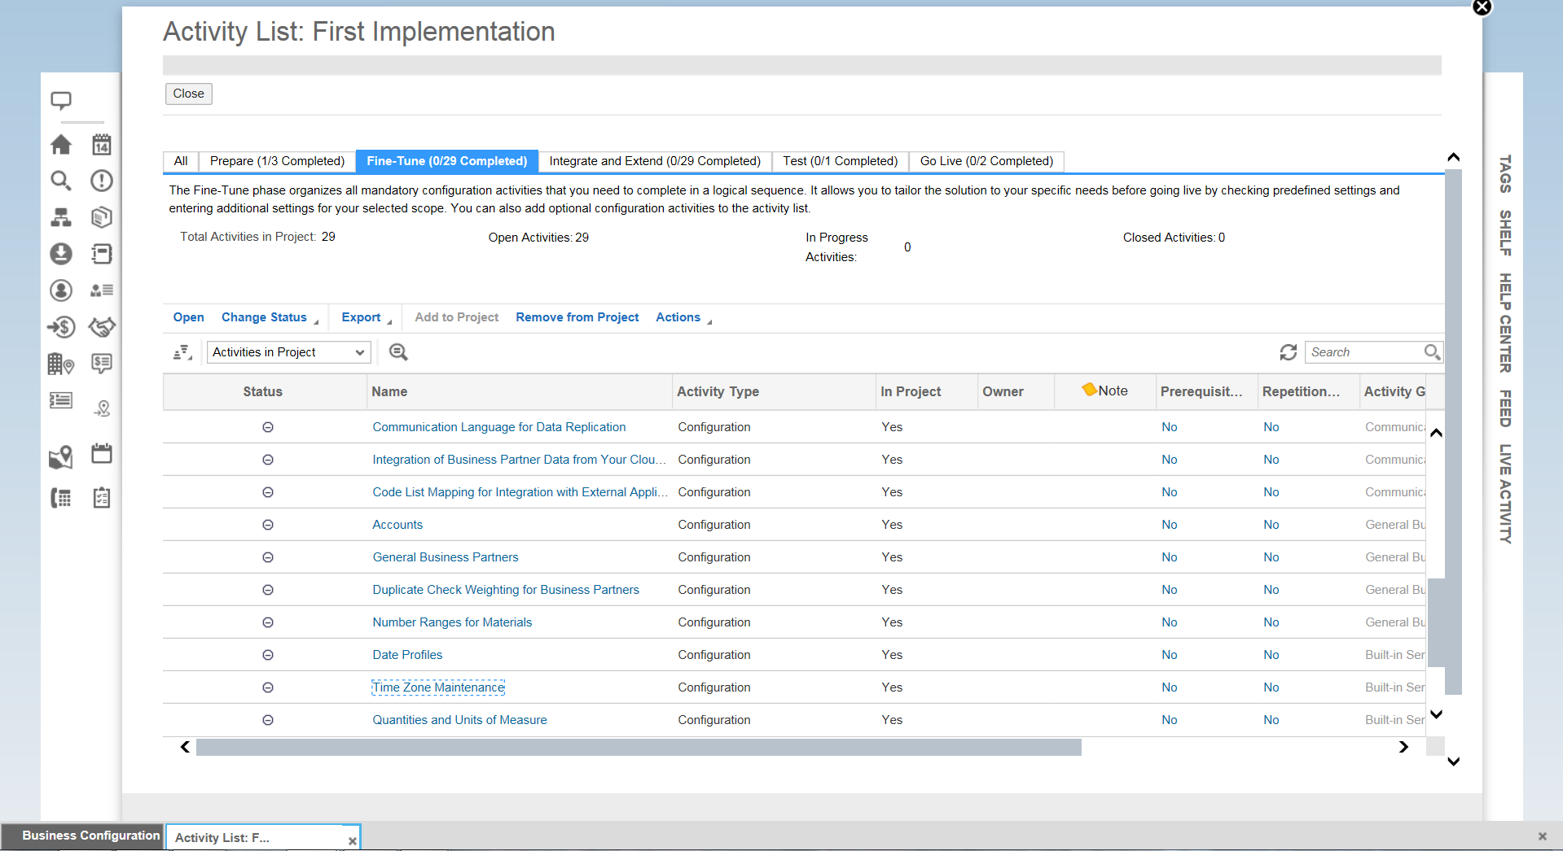

Define Number Ranges in C4C
Transaction | N/A | Define Number Ranges
Menu Path | Business Configuration Implementation Projects Open Activity List Fine-Tune General Business Partners Number Ranges for Business Partners

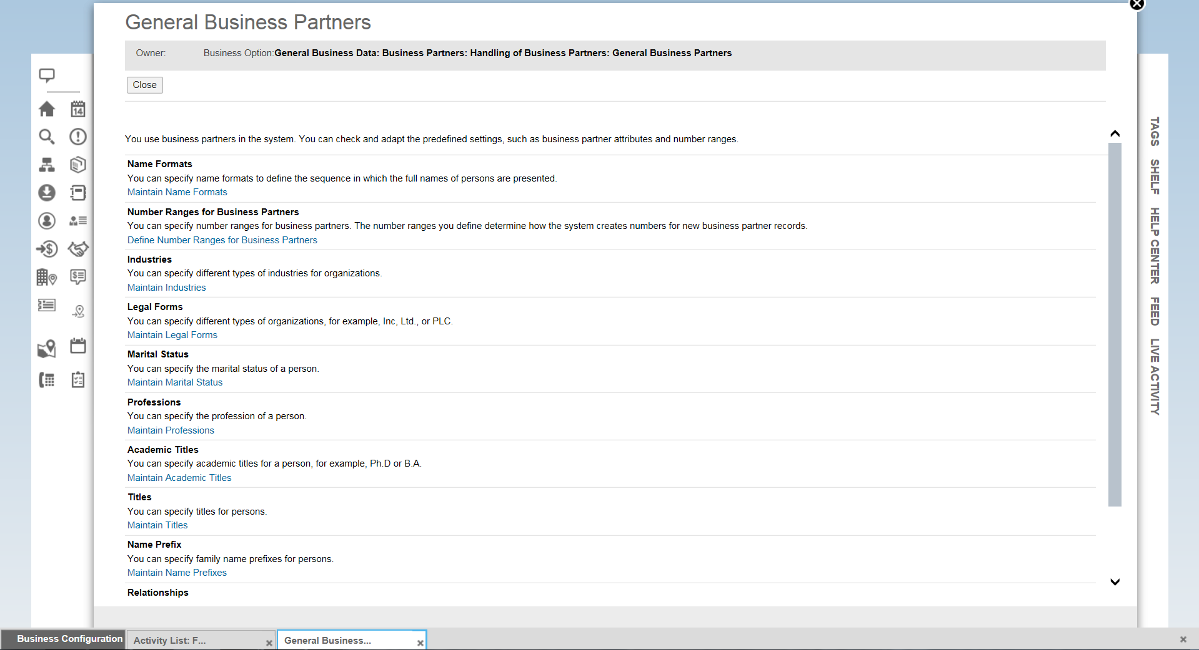
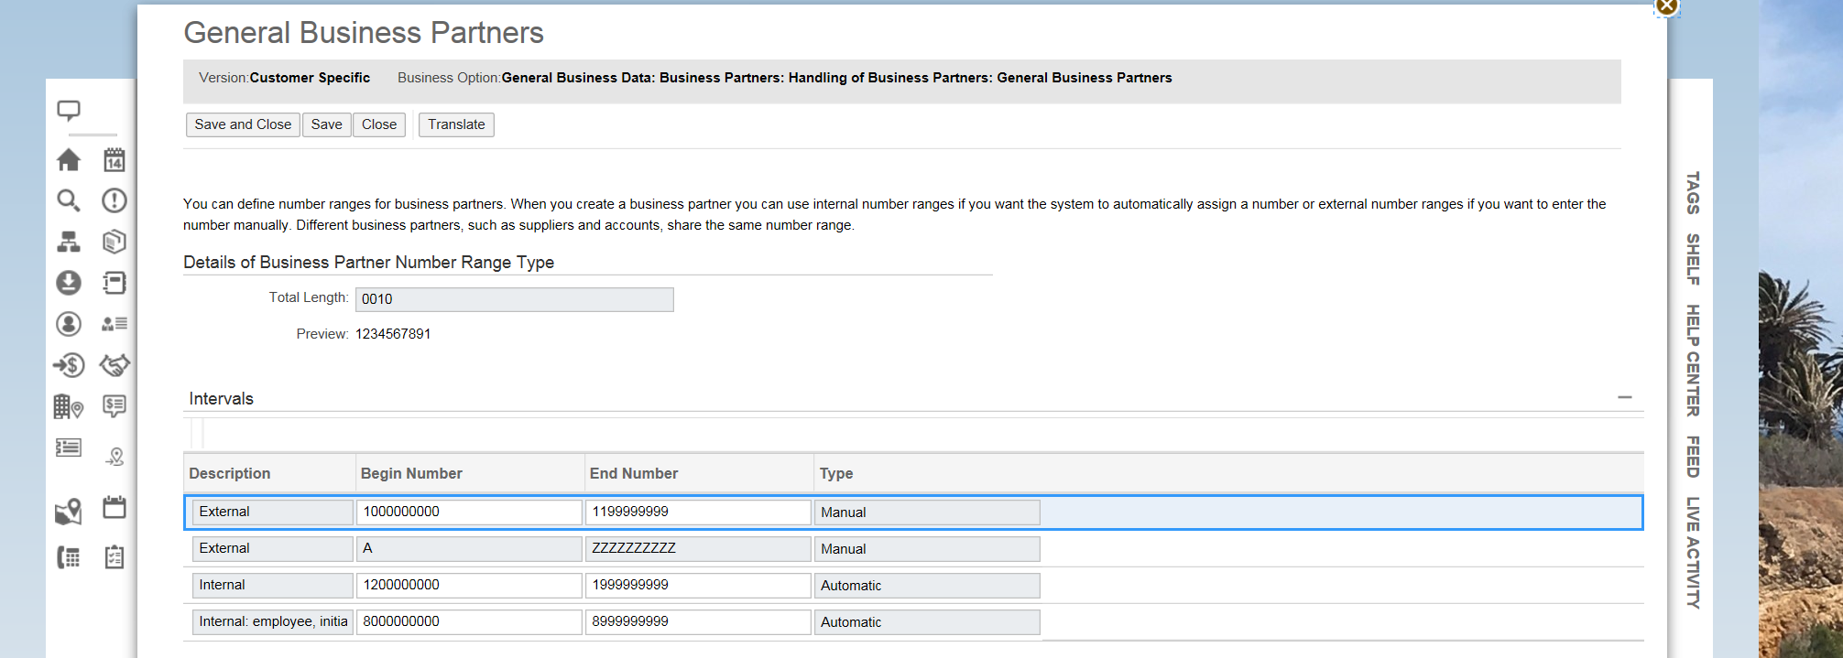

Define BP Relationships in C4C
Transaction | N/A | Define BP Relationships
Menu Path | Business Configuration Implementation Projects Open Activity List Fine-Tune General Business Partners Number Ranges for Business Partners

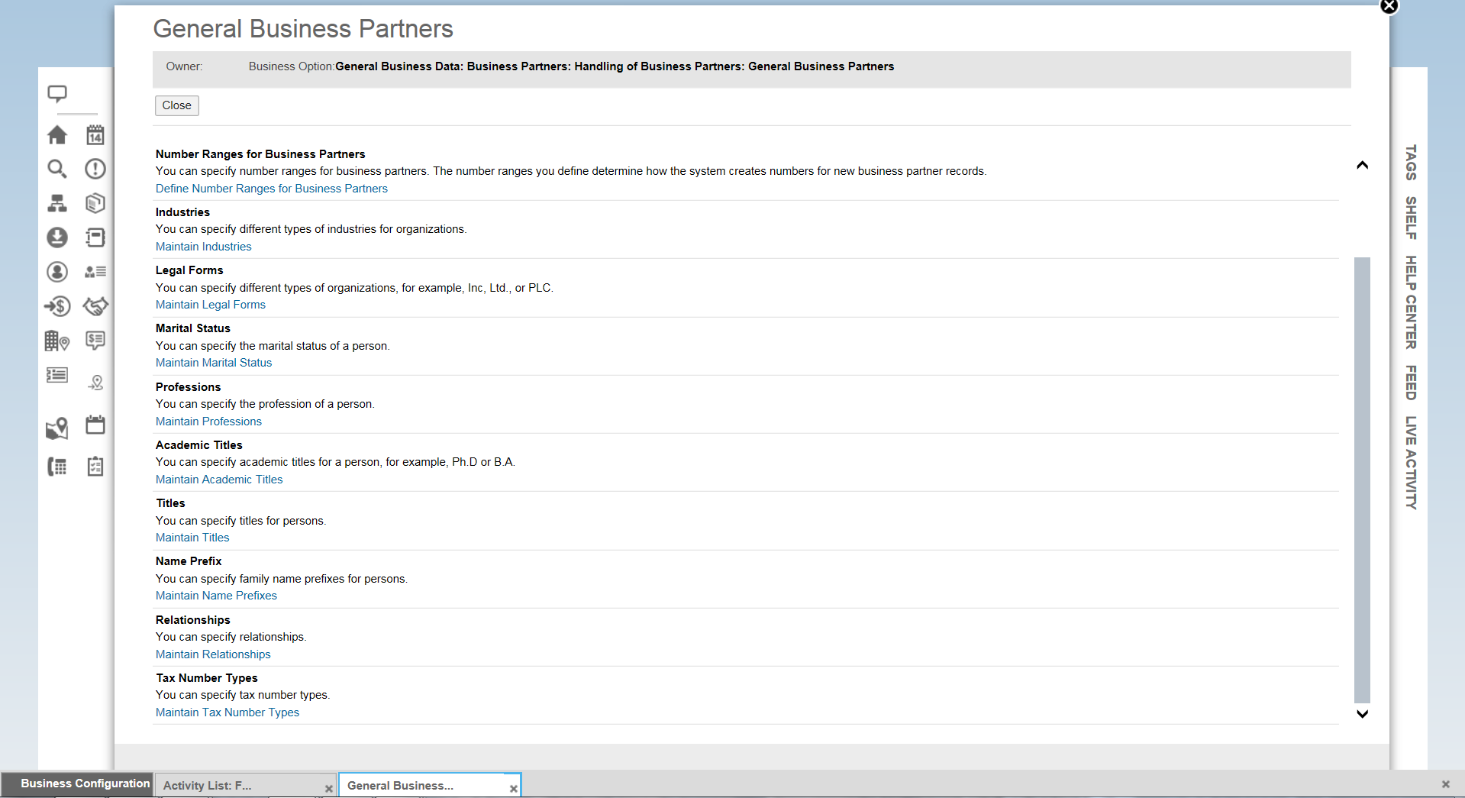
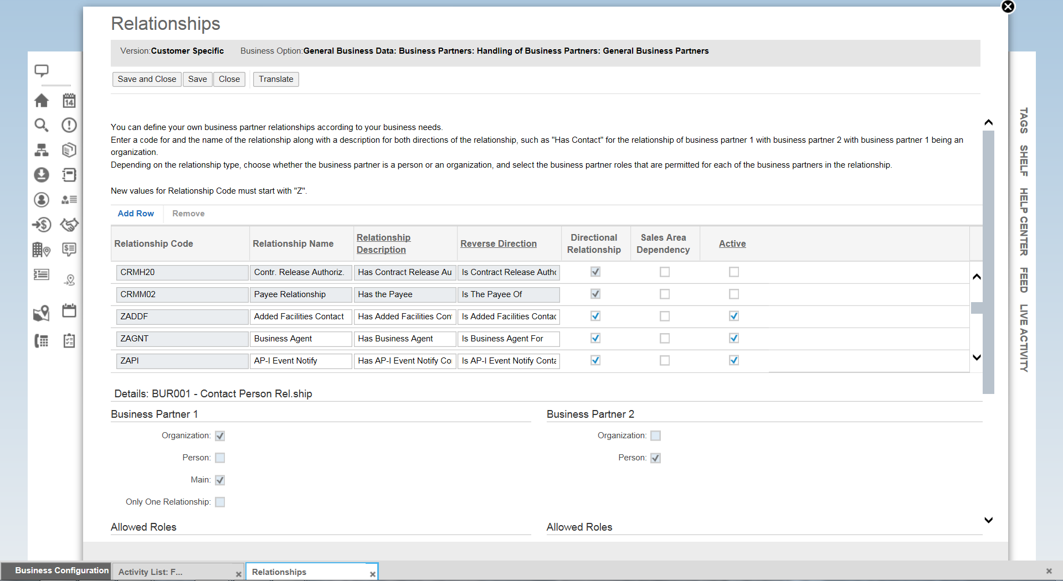

Adding Fields to Various Screens in C4C
Transaction | N/A | Adding Fields to Various Screens
Menu Path | Launch HTML5 Adapt Edit Master Layout

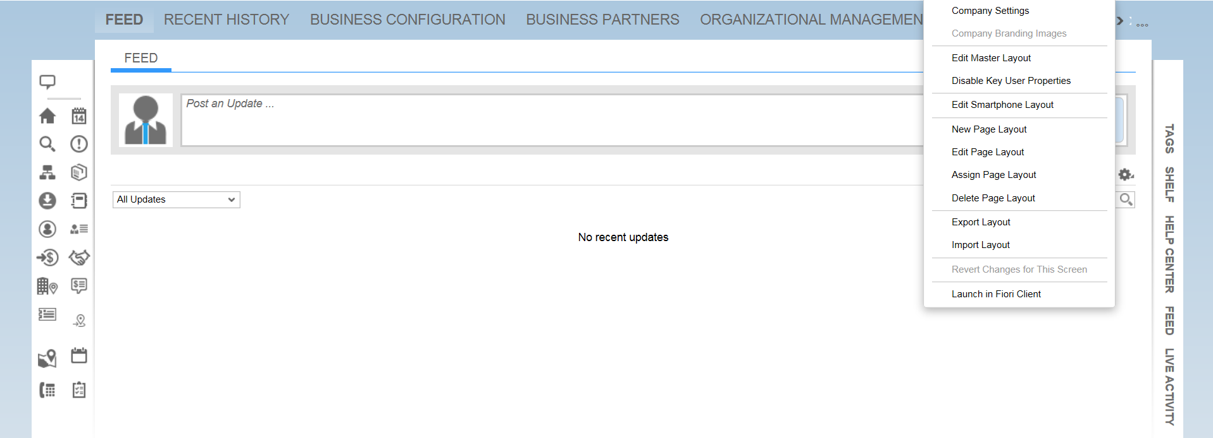
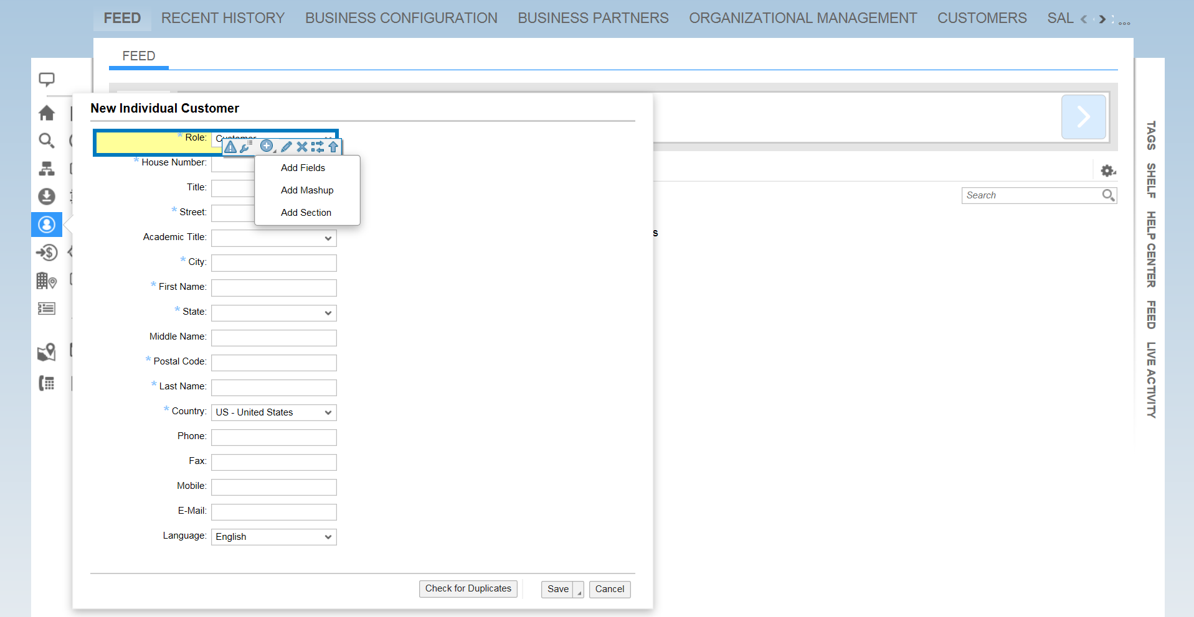
*Wrench allows you to hide or make fields visible
*Plus sign > Add Fields allows you to add additional fields to the screen
*Pencil allows you to change the name of the field
**This needs to be done screen-by-screen. For example, the above screenshot is adjusting the “Create Individual Customer” screen. To adjust the “Create Account” screen, you would need to select that icon on the left-hand side of the screen and then repeat the above steps.
**To adjust screens that are seen once a BP is confirmed, click on “Shelf” on the right hand side of the screen and select a BP from your favorites list. Once this is opened, you will see the tabs across the top of the screen as you would in the normal view. Click to the view you want and you can perform the 3 functions highlighted above on that tab.

